# Task 1

For the United Pet Care, the clinic operated by the two veterinarians Abraham, Brandon and an administrative staff Christina. They work in shifts. For Abraham, he works on Mondays, Wednesdays and Fridays; Brandon works on Tuesdays and Thursdays and Christina works on every weekday. For calculating the operational cost for the clinic standard 5 working days are considered. Following table depicts the total amount of cost.

|  |  |  |  |  |  |
| --- | --- | --- | --- | --- | --- |
| **Name** | **Day Count** | **Shifthour** | **Shift Hours Every Week** | **Cost/hour** | **Cost/Week** |
| **Abraham** | **3** | **6.5** | **19.5** | **45** | **877.5** |
|  |  |  | **0** |  | **0** |
| **Barnardo** | **2** | **6.5** | **13** | **38** | **494** |
|  |  |  | **0** |  | **0** |
| **Christina** | **5** | **3.5** | **17.5** | **30** | **525** |
|  |  |  |  |  | **0** |
|  |  |  |  |  | **0** |
| **Cost for Replacement worker for Vets @49** |  |  | **32.5** | **49** | **1592.5** |
|  |  |  |  |  | **0** |
| **Cost for Replacement worker for Staff @39** |  |  | **17.5** | **39** | **682.5** |
|  |  |  |  |  |  |
| **Total Cost for Replacement worker** |  |  |  |  | **2275** |
| **Annual Payment as Wages** |  |  |  |  |  |
| **Abraham** | **45630** |  |  |  |  |
|  |  |  |  |  |  |
| **Barnardo** | **25688** |  | **Required Income for every Month** | 10731.83 |  |
|  |  |  |  |  |  |
| **Christina** | **27300** |  |  |  |  |
|  |  |  |  |  |  |
| **Replacement Worker** | **9100** |  |  |  |  |
|  |  |  |  |  |  |
| **Total labour Cost** | **107718** |  |  |  |  |
|  |  |  |  |  |  |
|  |  |  |  |  |  |
|  |  |  |  |  |  |
| **Insurance Cost for United Pet Care** | **16384** |  |  |  |  |
|  |  |  |  |  |  |
| **Utility cost Electricity and Gas @390** | **4680** |  |  |  |  |
|  |  |  |  |  |  |
|  |  |  |  |  |  |
| **Total Operational Cost** | **128782** |  |  |  |  |
|  |  |  |  |  |  |

From the above table, the total operational cost for the clinic is $128782. In order to cover the operational cost, the required monthly income from the clinic have to be at least, $10732.

In case the both veterinarians were to cost $45 per hour, but the clinic closed on Fridays, then the number of working days will be reduced for the employees. In that scenario the projected annual cost will be $106292.

# Task 2

For the emergency visits the following plot is generated.

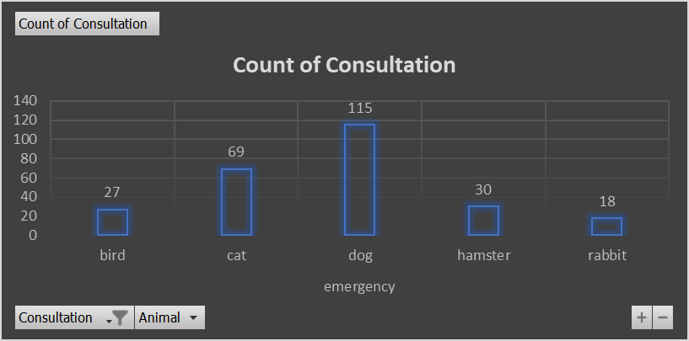

From the above plot, it can be stated that the maximum number of emergency visits are from dog patient owners and lowest number of emergency visits are from rabbit pet owners.

As the clinic is planning to run discount day for dog check-ups, while reducing the emergency visits then number of highest emergency visits are plotted below;

As depicted above, lowest number of dog emergency visits are on Wednesdays therefore it is suggested to run the discount day on Wednesdays. On the other days there are higher number of visits from the dog pet owners that may lead to lesser amount of revenues.

# Task 3

Consultation for different animals are plotted in the below bar plot.

For dogs and cats the number of visits is highest in different months. While investigating the number of visits recorded highest in the month of the September. In case of check-up consultation there are hikes in the bars are noticed for the month July and November.

Time wise or month wise comparison is also done. For the same the following Doughnut chart is plotted.

From the above plot, it can be stated that highest amount of revenue generated in the month of October and lowest amount is recorded for the month of December.

In the last section the amount of revenue/expenses generated by the veterinarians.

The above chart shows 57% of the revenue are generated by Abraham and 43% of the revenue is generated by Barnardo.

# Task 4

As there are 5 types of animals and 4 types of consultation available in the clinic thus in order to quote a consistent price for the different animals and their required consultations. For the quote the AVERAGEIFS inbuilt formula is utilized depending on the range of values and criterions. For the same the following table is created and available in the excel file.

|  |  |
| --- | --- |
| **CHOSE ANIMAL** | **dog** |
|  |  |
|  |  |
|  |  |
| **CHOSE CONSULTATION TYPE** | **other** |
|  |  |
|  |  |
| **COST** | **165** |
|  |  |

Other formulas used are, data validation for the selection of the criterions. The AVERAGEIF built in function is helpful in calculating average of a series of cells which meets the specified criterions. In this case the type of animal as well as the type of consultations.

# Task 5

For the business process improvement, the following swim lane diagram is diagram is plotted.

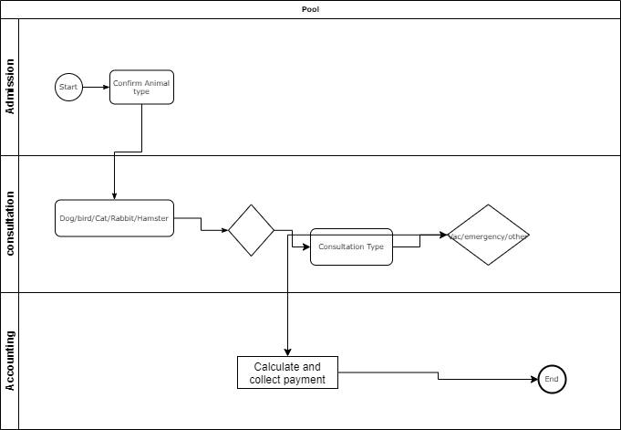

Trend of price over different months;